StackOverflowQuick LaunchProviderallows you to searchStackOverflowwithinVisual Studio.

Just press Ctrl +Q or click inside Quick Launch search box and start typing your question.

When you click ona selected search resultyou will be redirectedto the StackOverflow's site.

This extension works with Visual Studio 2012 and VisualStudio 2013.

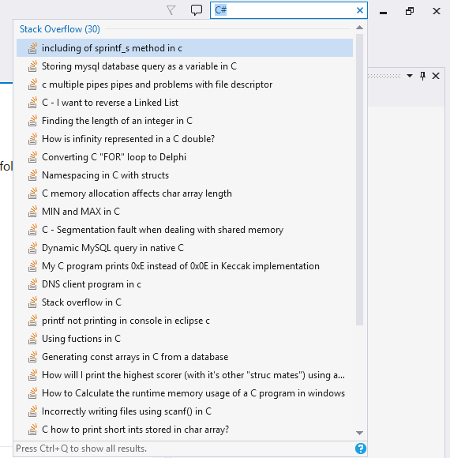

Versions:

* 1. First preview release

search, quicklaunch, Stack Overflow